Packet Filtering and Analysis using Wireshark/Burp Suite

Aim
To capture, filter, and analyze network packets using Wireshark on Kali Linux in VirtualBox.

Tools Required
- Hardware: Laptop/PC with VirtualBox installed
- Software:
  - Kali Linux (running inside VirtualBox)
  - Wireshark Network Analyzer
  - Apache2 web server
  - PHP interpreter
  - Browser

Procedure
- Configure VirtualBox Network for Packet Capture
  - Open VirtualBox → Kali VM → Settings → Network.
  - Set Adapter 1:
    - Attached to: Bridged Adapter
    - Promiscuous Mode: Allow All
    - Cable Connected: ✔️
  - Save settings.
- Start Kali Linux VM
  - Boot the Kali Linux VM in VirtualBox.
- Run Wireshark as Root
sudo wireshark
  - Select network interface eth0
- Start Packet Capture
  - Click on eth0 to begin capturing packets.
  - Generate some traffic (open websites, ping servers, or run curl commands).
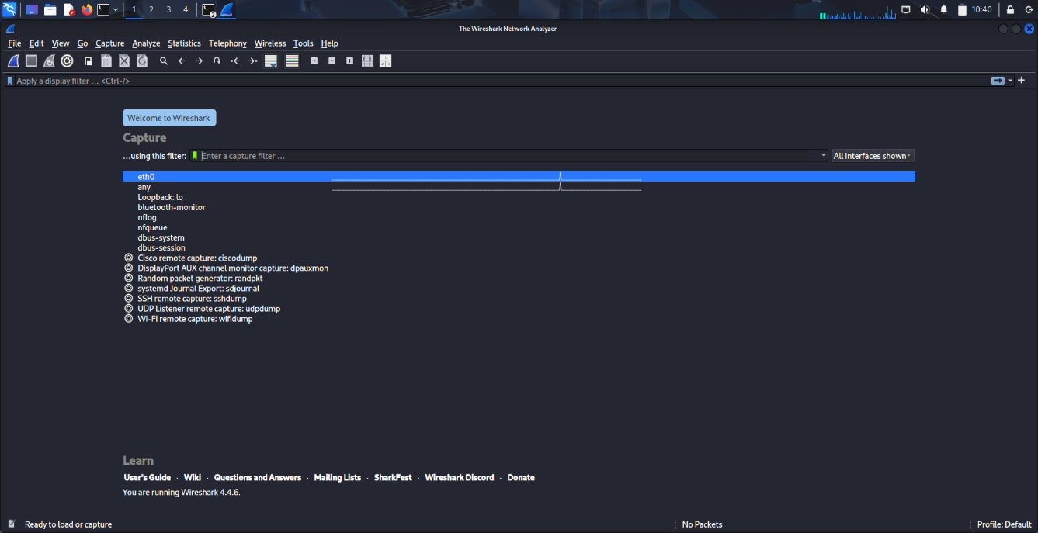
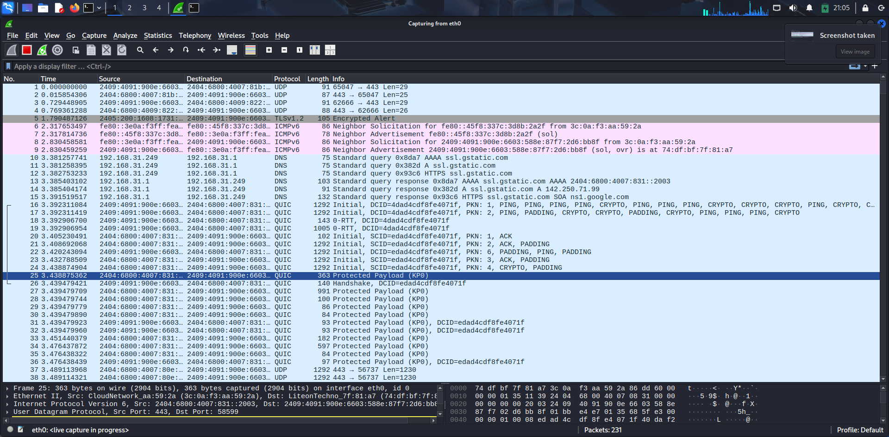
- Apply Display Filters for Analysis
Examples:
  - DNS Packets:
dns
  - HTTPS Packets:
tls
  - Packets from specific IP:
ip.addr == 18.161.216.37
  - TCP Port 443:
tcp.port == 443

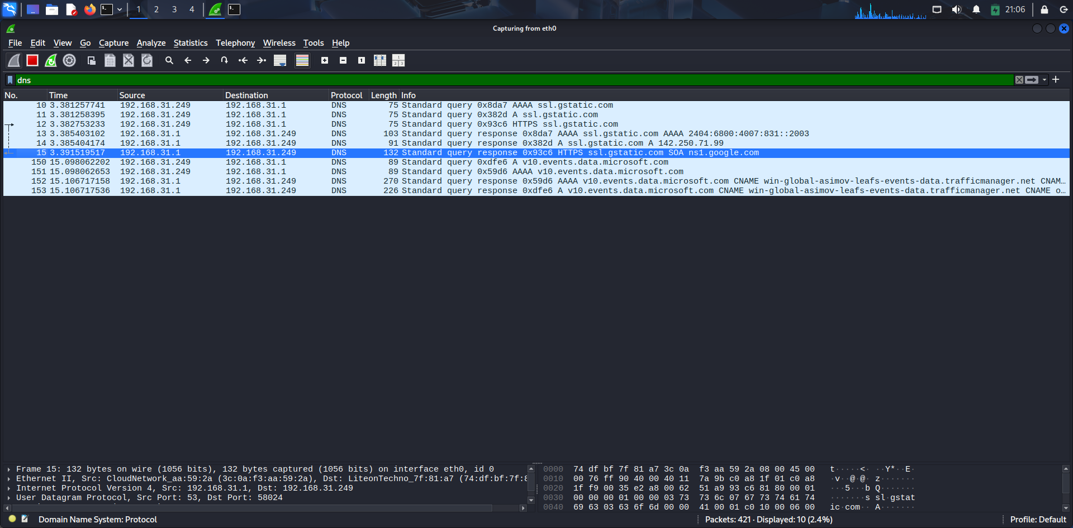
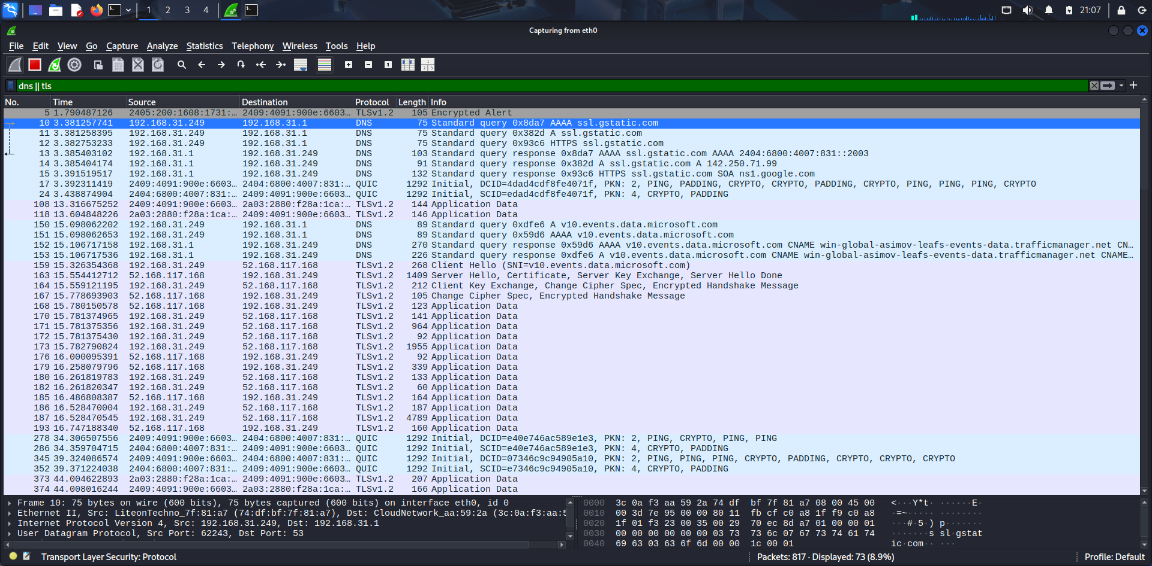
- Analyze Captured Packets
  - Select any packet and expand:
    - Ethernet Layer: Source & Destination MAC addresses
    - IP Layer: Source & Destination IP addresses
    - TCP/UDP Layer: Port numbers, flags (SYN, ACK)
    - Application Layer: Protocol details (DNS query, HTTP request, TLS handshake)
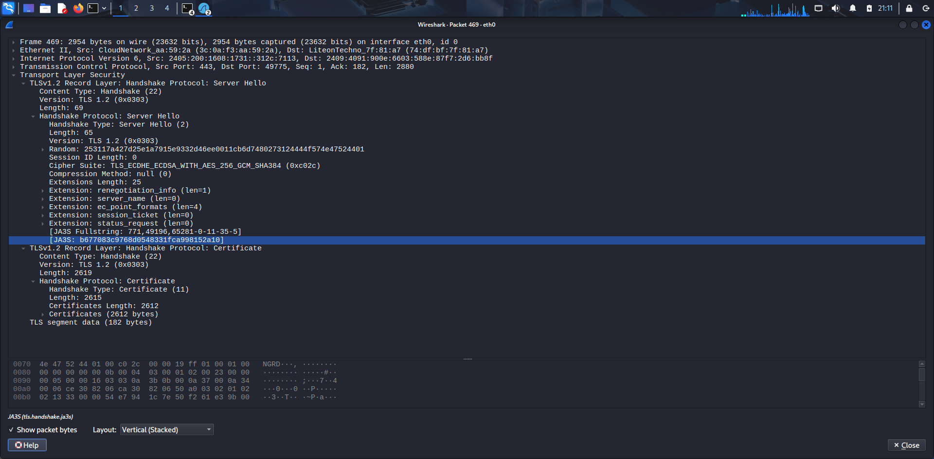
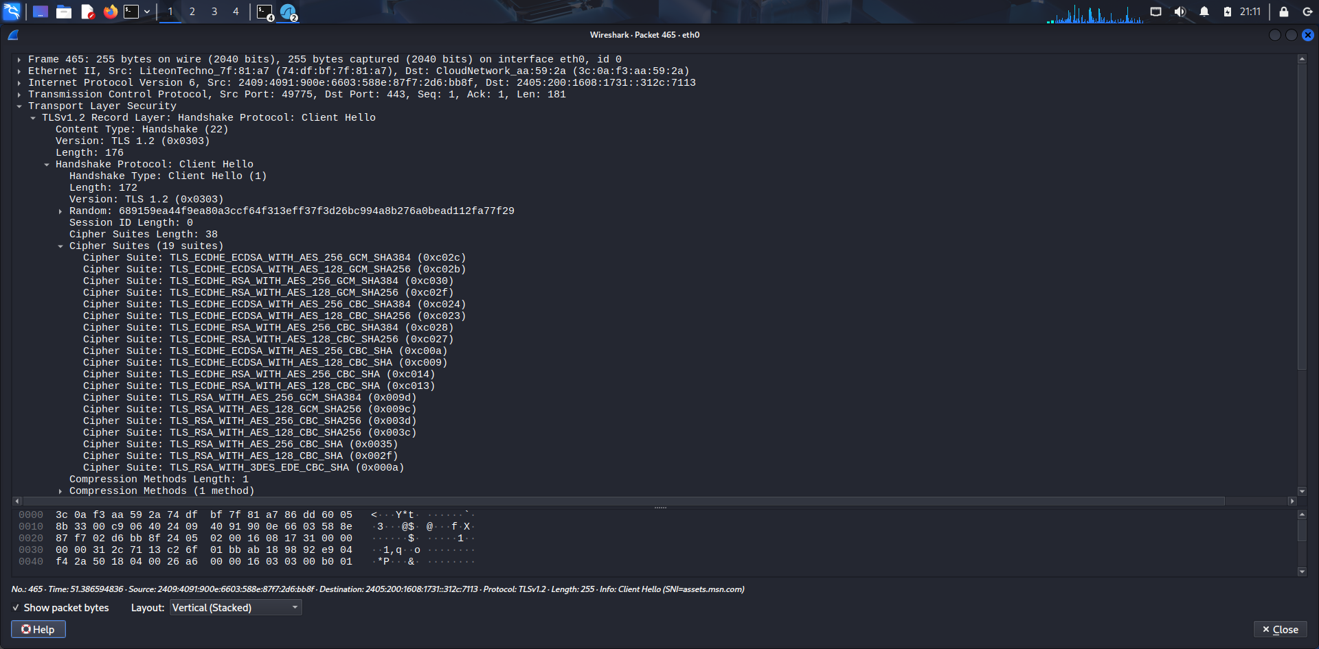
- Stop Capture and Save
  - Stop capture (red square button).
  - Save capture file in .pcap format for submission.

Part B: Capturing Login Credentials over HTTP
Step 1 – Setup Apache Web Server
sudo service apache2 start
sudo mkdir -p /var/www/html/testlogin
cd /var/www/html/testlogin
Step 2 – Create Login HTML Page
sudo nano login.html

html
CopyEdit
<!DOCTYPE html>
<html>
<head>
<title>Test Login Page</title>
</head>
<body>
<h2>Login Form</h2>
<form action="login.php" method="post">
Username: <input type="text" name="username"><br><br>
Password: <input type="password" name="password"><br><br>
<input type="submit" value="Login">
</form>
</body>
</html>
Save (Ctrl + O → Enter → Ctrl + X).
Step 3 – Create PHP Script
sudo nano login.php

php
CopyEdit
<?php
$username = $_POST['username'];
$password = $_POST['password'];

echo "<h2>Login Attempt</h2>";
echo "Username: " . $username . "<br>";
echo "Password: " . $password . "<br>";
?>
Step 4 – Start/Enable Apache
sudo service apache2 status
sudo service apache2 start
Step 5 – Test Page
Browser:
http://127.0.0.1/testlogin/login.html
Or: Type in bash
curl http://127.0.0.1/testlogin/login.html
Step 6 – Capture with Wireshark
- Open Wireshark → select lo (loopback) interface.
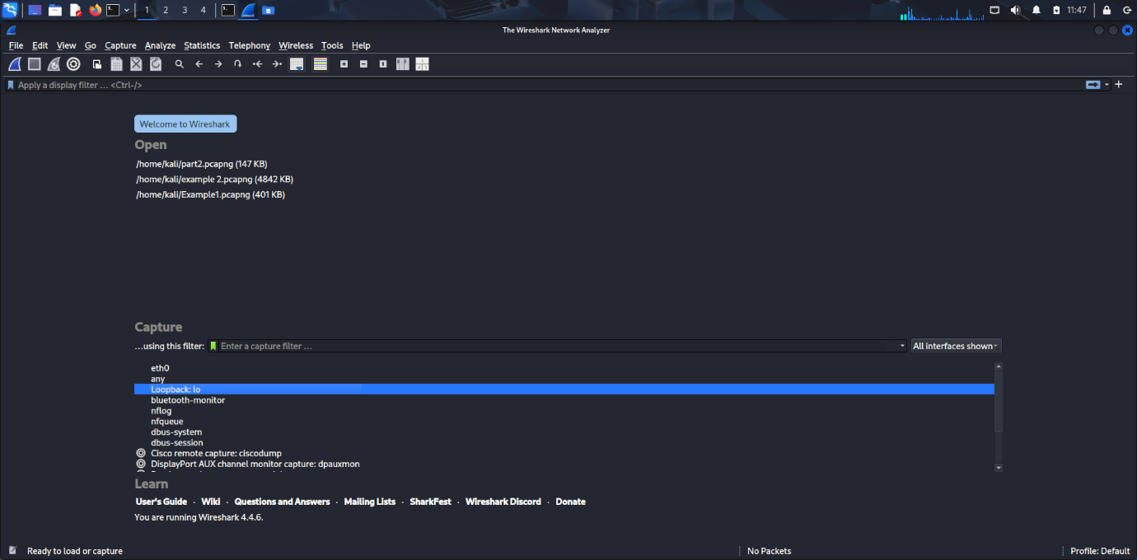
- Start capture.
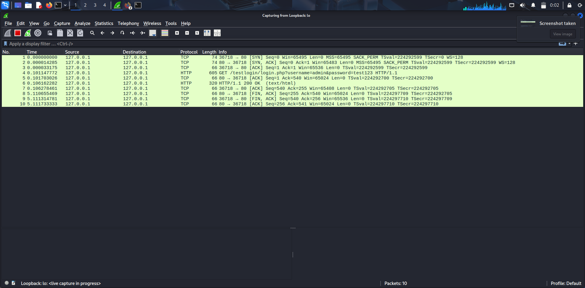
- Apply filter:
http.request.method == "POST"

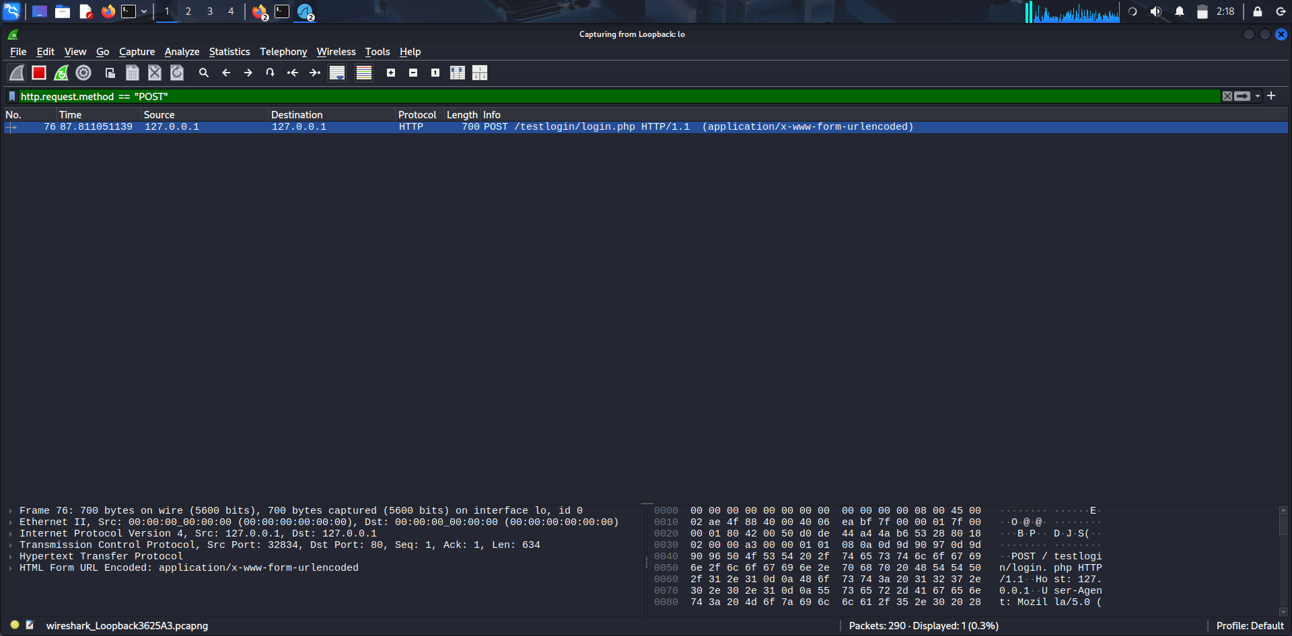
Step 7 – Perform Login Attempt
- Username: admin
- Password: test123
- Submit form.
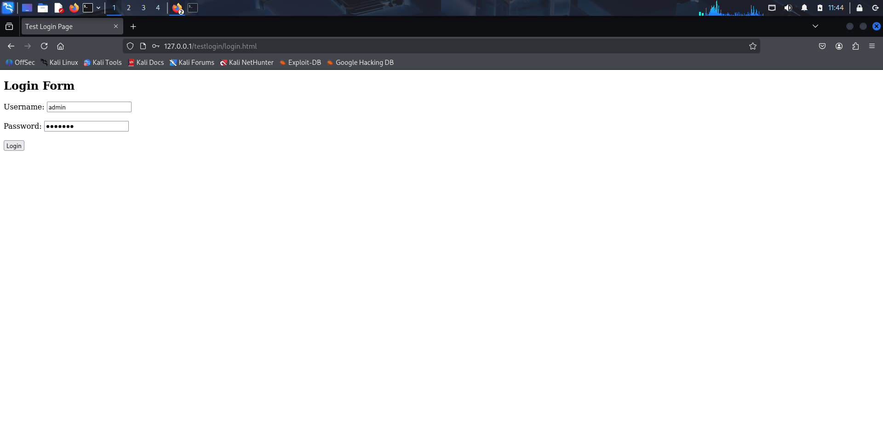
Step 8 – Analyze Packets
- Locate POST packet.
- Right-click → Follow → TCP Stream.
- Credentials will be visible in plain text.
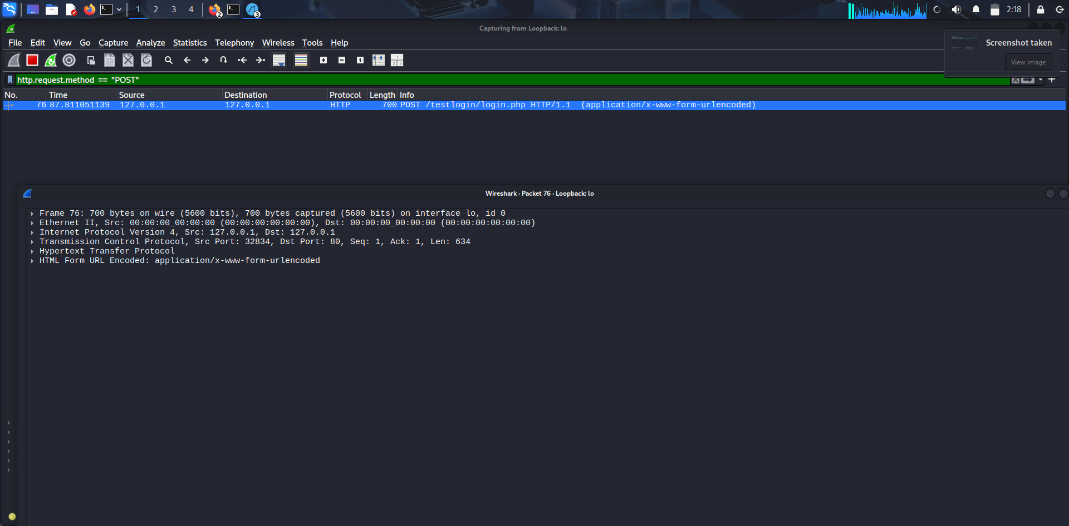

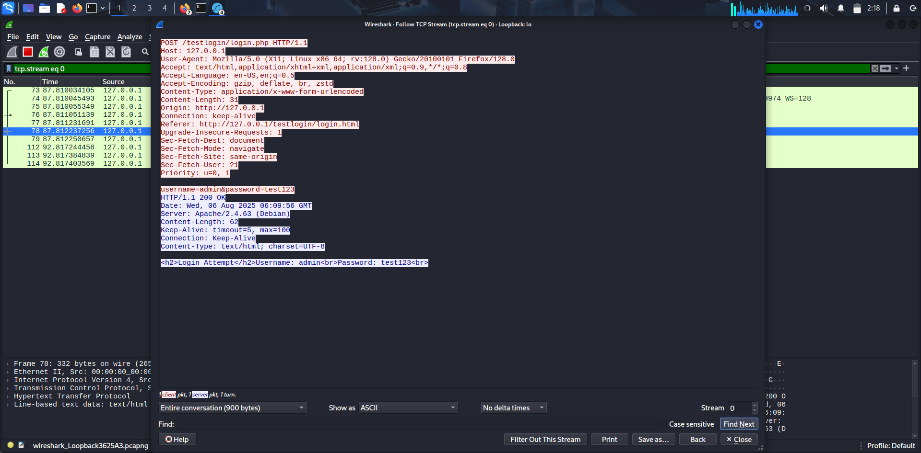

Observations
- Network traffic from various applications can be captured in real-time.
- Protocol filters help narrow down the traffic of interest.
- Details such as source/destination IP, MAC addresses, ports, and application data can be examined.
- HTTP POST requests transmit data in plaintext.
- Credentials can be directly read in the captured packets when using HTTP.
- Using HTTPS would encrypt this data and prevent such interception.

Post-Lab Discussion
- Bridged Adapter mode allows the VM to be part of the physical network, enabling packet sniffing.
- Promiscuous mode is essential to capture packets not directly addressed to the capturing machine.
- HTTPS traffic is encrypted, so packet payloads are unreadable without decryption keys.
- HTTP lacks encryption, making it vulnerable to credential theft.
- Tools like Wireshark can be used by attackers to sniff sensitive data if encryption is not in place.
- Transitioning to HTTPS mitigates this risk by encrypting data in transit.
- The loopback interface captures traffic within the local system (127.0.0.1).

Viva Questions
- What is the difference between a display filter and a capture filter in Wireshark?
- Why do we use promiscuous mode in packet capturing?
- How can you identify a TCP three-way handshake in Wireshark?
- What is the difference between HTTP and HTTPS in terms of packet analysis?
- Can Wireshark decrypt HTTPS traffic? Under what conditions?
- Why are credentials visible in HTTP packet captures but not in HTTPS?
- What is the significance of the loopback interface (lo) in Wireshark?
- How can a POST request be identified in Wireshark?
- What is the difference between GET and POST methods in HTTP?
- How does HTTPS protect against packet sniffing attacks?

